Unit 4 I used to be afraid of the dark Period 1
学习目标：
知识目标：口头及书面掌握句型：
- A：What would you do if you had a million dollars? B: I'd give it to charity.
- If I were you, I'd take a small present.
- If I were you, I'd wear a shirt and tie.
熟练掌握词汇：million, medical, research, tie, worry, what if.
技能目标：1.理解表示与现在相反的虚拟语气的结构
2.学会运用if 描述一些假设的、虚拟的情况
情感目标：通过谈论假设、虚拟的情况，增强自己的爱心和对美好事物的向往。
课前探究：
如果你有很多钱，你会做些什么?( 放飞你的梦想，把你的观点写下来 )
- I would_________________________________
- I would also ___________________________________
- I would________________________________ as well.
预习交流
Before listening Pairwork: Do 1a.
While listening
- Do 1b. 2.Listen again and complete the dialogue.
A.give the money to medical research
B.put the money in the bank
C.buy a big house for my family
D,give the money to the zoo
E.gave it to chairty

Girl1:Hey, did you see this newspaper article? An old man had a million dollars. And he ___.
Boy1:Wow, what a nice man!
Girl1:What would you do if you had a million dollars?
Boy1:If I had a million dollars, I'd _________ . I want to help the pandas.
Girl1:That's a good idea! I know what I'll do. I'd _____.
Girl2:Really? I'd _____ . Then I'd just watch it grow!
Boy2:Hmm, I think I'd ______________. I'd want to help other people.
- 跟读，然后分角色朗读。 4.Pairwork: 1c.
互助提升
1. What would you do if you had a million dollars?
这是一个虚拟语气的句子，虚拟语气是表示一种假设、愿望、建议或是一种不可能实现的愿望。它常用在条件句及其他一些从句中。通常与现在或将来事实相反的假设。
主句使用_________ .其结构为：主句（would/could/might + _________)+if从句(过去时).（be动词任何人称都用_______）；与过去事实相反的假设，例如：If you had come yesterday, you would have seen him.主句是_________（could, might）+have done, 从句用_______done.
练习：1）If you ________ (hear)the news , you would have known the meeting.
2）If I ________ a bird, I would fly free in the sky.
3）If she _______free, she _______ ______ to see you.
2a,2b
- Do2a. 2. Do2b
3. Listen again and complete the dialogue.
- you can leave. B.you can talk to Tom.
- C.what other people are wearing
D.take a small present E.if I were you
F.what to wear

Girl: Where are you going, Larry?
Boy: To Tom's party.
G:Lucky you! I'd love to go to that party.
B:Yeah, well, I'm a little nervous. I don't know ____.
G:____, I'd wear a shirt and tie.
B:What if everybody else is wearing jeans and T-shirts?
G:Oh, you shouldn't worry about_______________.
B:And I don't have a present. What if everyone brings a present?
G:If I were you, I'd _________ -a pen or something. Keep it in your pocket and if everyone has a present, you can give him yours. If not, you can keep it.
B:OK. But what if I don't know anyone?
G:If you don't know anyone, ______. He'll introduce you to people.
B:I guess I can do that;
G:Look! You're sure to have fun. But if you're still nervous, __________.
2. Pairwork: Role play.
What if ... 相当于What will/ shall sb. do if...? 意为________, 用来询问如果发生什么事的时候，某人该怎么办。如： __________ the weather is really bad?
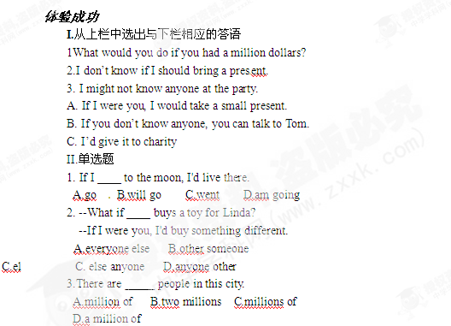
各小组交换检查练习结果，评出成绩（总分6分）_____，老师对各组成绩汇总，给出评价。
组内讨论错题，老师点评。
快乐心得
- 我帮助了_________同学说____________。
- ________同学帮助我学会了___________.
- 我在课堂上与同学对话________次。
- 我对我在课堂上的________________（表现）感到满意。
- 本堂课我还有________________不懂。
拓展延伸
I.如果你去参加一位美国朋友的聚会，你需要注意什么？
__________________________________________________________________________________________________________________________________________________________
II.你还有哪些知识没有掌握？做出标记。

